21.61: a) Changing the orientation of a dipole from parallel to perpendicular yields:
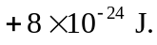

b) 